**Research Proposal on Carnival Corporation & PLC (Carnival)**

**Kamilla Issakova, Zhaniya Bakizova, Yernat Bakyt**

**ISE 2021**

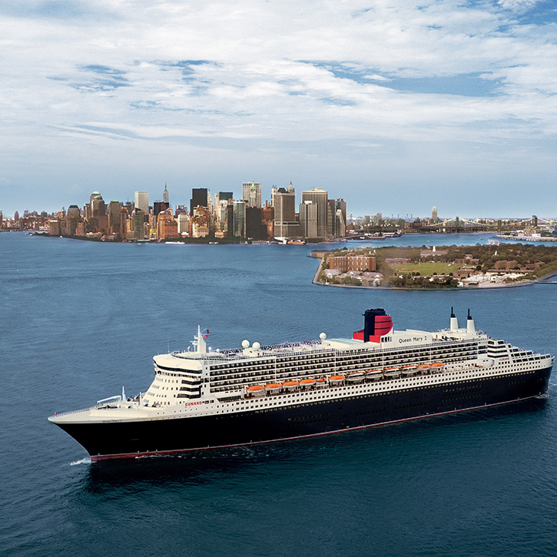

Table of Contents

Background 2

Problem Definition 2

Research Objectives 3

Research Design 3

Sampling Method 4

Fieldwork 7

Questionnaire Design 8

Data Processing and Analysis 8

Appendix 10

## Background

Upon the start of Covid-19 the prohibition on sails of the cruises was imposed as the concerns on the risks of infection started spreading. The world cruise industry has been brought to its knees after appropriate government health regulations restricted ships from sailing to limit the coronavirus outbreak. The perception of cruise ships invoked by the media appeared to turn out in a rather detrimental way – that cruise vessels started to refer to as “floating Petri dishes”, alluding that the biggest coronavirus outbreak outside mainland China is not a country, but rather on a cruise ship.

As of the first quarter of 2020, the number of cruise ships that have confirmed to report cases of Covid-19 documented onboard was over 50.[1] Cruise industry is being popular at its most among the older population and the latter is at a particular risk of Covid-19 infection.

With its revenues on rock-bottom levels, Carnival, being the world’s largest leisure travel company, has reported losses accumulating for $1.9 billion on an adjusted basis for its quarter ended Nov.30, 2020.[2] Therefore, alongside its competitors, the company has spent the rest of 2020 in effort to get by, by taking new loans and trading its ships and shares. As a result, Carnival has raised a total of $19 billion in debt and equity and subsequently ended the year with $9.5 billion in cash.

Now that the Centers for Disease Control and Prevention has been approving the cruise vessels for limited sailings in compliance with the Framework for Conditional Sailing Order guidelines, which included test voyages with volunteers, the industry appears to have a ground for rehabilitating, albeit rather slow.

## Problem Definition

Rebuilding the public trust of the cruisers considering the new health and sanitation measures is the leitmotif of the Carnival in terms of the business research objectives. It is crucial to examine the Risk Perception Attitude framework[3] given how the Covid-19 affected the mindset and hence the willingness of cruisers to employ that kind of leisure.

The preposition on the concerns of the cruisers and the change of the perception of cruising since the start of the pandemic are of a high interest of this study. Overall research also intends to derive the possible marketing strategies necessary to alleviate the concerns of the customers, whilst sustaining the loyalty of the latter and persuade non-cruisers to consider switching to a cruise for their next holiday.

Going beyond the problem identified in the research brief by the client, the staff employability is also of high interest given the further data analysis of the research. The Cruise Line Industry Association has reported to have 1.2 million jobs supported by its members before the pandemic hit.[4] As of the Carnival Corporation case, along with having nine cruise brands in its portfolio such as Carnival Cruise Line, Princess Cruises, AIDA and Cunard, the company employs approximately 150,000 people worldwide in around 150 countries. The worldwide prohibition on sails has not only put the cruisers in a position of abstinence upon favorite leisure activity, but it also deprived many employees of labor. The latter has had an explicit effect on the economy, taking into consideration the fact of impossibility of cruise employees to work remotely.

## Research Objectives

Research objectives cover broader areas of the research in terms of the following research questions, that are to be explored through the research methodology.

1. How the perception of cruising have changed since the start of the pandemic;
2. How did the corporate image of the Carnival change in the minds of (1)customers, (2)staff;
3. How the Risk Perception Attitude (RPA) towards the Covid-19 pandemic affects intentions to cruise;

## Research Design

Proposed research design of the study is descriptive (cross-sectional). Cross-sectional research design involves the collection of necessary information once from any given sample of population elements. The descriptive research method can be used in several ways and for different reasons. Before proceeding to any question, to the end, the objectives of the survey and the design of the survey are crucial, since in the future we chose an online survey, this method is perfect for our work.

A quantitative observation technique is employed extensively in descriptive research. This would yield records on the behavioral patterns of respondents, as well as the objects and events in a systematic manner to obtain information about the phenomenon of interest - in our case, in accompaniment with the Risk Perception Attitude framework, a quantitative observation technique would help to unleash the patterns on the perception of cruise leisure after the pandemic.

Considering the timescale of the research, a cross-sectional study would be prospectively conducted within three months. Three-month window and a cross-sectional manner of the study does not however give an access to assess how risk perception may change over time in exploratory manner, however, this could be done in terms of the questions asked in the questionnaire. The structured questionnaire is used to obtain the data in need: it is affordable to collect and moreover goes along well with the purpose of collecting purposeful information.

The data collected may be subject to the social bias, by the virtue of the self-report nature of the study and the individual behaviors.

## Sampling Method

The target population to be observed is cruisers along with non-cruisers and staff workers. It is therefore vitally important that every sample out of a given customer base would be representative of the population of cruisers. The simple random sampling (SRS) could have been recruited unless the population would be geographically diverse, which makes SRS impractical and costly. Having that the customer base for cruisers is already provided, it is explicit that cruisers are also subject to different demographic groups - e.g. age, gender, ethnicity and religion. In compliance with the research objective to study different demographic profiles, it is necessary to take a subgroup of the population and therefore study it within.

The chosen sampling method therefore ought to be the stratified two-stage cluster sampling method. The sample therefore would concentrate on two criteria, while being a reliable representative of the population. As the name suggests, a stratified two-stage cluster sampling method incorporates a combination of both stratified and cluster sampling methods.

Cluster is defined as a rather natural grouping of people (e.g. cruise customers) formed by a common geographical area (country), region, town, company, department or household. The sampling here is done on a population of these clusters, hence, cluster is being considered a sampling unit. Cruise customers are spread globally and in accordance with the statistics provided by the Carnival Corporation & PLC, as of 2018, the number of guests worldwide carried was approximately 5.4 million.[5] Given that the population of customers are being widely scattered around the globe, it is reasonable to discriminate the population by the geographical area - country. Upon grouping the population into clusters and numbering them, it is necessary to use a random number of the latter to be drawn. We are obviously particularly interested in the most dense areas, therefore the machine-learning based instrument known as a Density-based Spatial Clustering of Applications with Noise (DBSCAN) comes into usage. This tool detects areas where points (customers in context of our problem) are concentrated. Typically, after having selected a number of the most densely populated clusters, every individual is sampled, however we are striving to go forth and infuse the sampling plan with the stratified sampling technique.

Stratified sampling technique associates with having a particular characteristic of interest in compliance with which strata are formed. In correlation with the aim of the research, that characteristic is age. Having provided that strata should be chosen in a way that the members of the same stratum are similar in terms of this characteristic, it is a reliable sampling method. There are going to be differences between the stratums having divided the sample by age (for example, age groups of 20-29, 30-39, 40-49, 50-59 and 60 or above). Generally, stratified sampling design falls into two categories: proportionate and disproportionate stratification. The intended category to be used is disproportionate stratification, where the sample size of each stratum is disproportionate to the population size and has a unique sampling fraction. Sample points are obviously going to be allocated differently from one strata to another: there may be more customers of the age group 40-49 than those of 20-29, so for over-sampled strata sampling fraction is going to be smaller and vice-versa. Therefore, different sampling fraction would lead to a greater precision and an adequate representation of the population.

The vital point of the stratified sampling technique is that our aim is to examine the differences between several heterogeneous subgroups, having members of each subgroup being homogeneous within.

Sampling method described above falls into the category of a multistage sampling approach. Hierarchical component of the multistage sampling is in staged acquisition of the sample: sampled stratified clusters are nested within clusters sampled at the previous stage. Moreover, the stagedness of the methodology along with the proportionate stratification leads to the reduction of the standard errors, thus to the gain in precision.

Sample Size

Decisions on a sample size are codependent with striking the balance between precision and cost. Particularly, the sample size ideally should be chosen in accordance with the decision on precision, where the latter depends on the amount of clustering. Intuitively, the larger the sample is, ceteris paribus, the more precise and accurate estimates would be. At this point, the sampling fraction needs to be identified. However, as of stratified clustering sampling method, a questionnaire on a large number of clusters (countries) with several customers being surveyed in each strata (age group) would yield more precise estimates than the one in which a lot of customers from each strata belonging to a smaller amount of clusters are being surveyed - this would lead to a bias.

Moving along the multistage principle suggested by the sampling method, selection of clusters is brevified by the Density-Based Spatial Clustering of Applications with Noise, followed by each cluster being stratified by the age group and finally, different sampling fractions applied to each stratum as explained above. At an extreme, having 195 countries in the world, stratified by 5 age groups, given the number of guests provided by Carnival above (5.4 million), each age group would on average contain approximately 5,600 individuals. These are implausible statistics, since samples for each age group vary significantly.

Having set 2,000 customers globally as the suggested minimum sample size, given the quantitative indicators as above, the sampling fraction would be 1 in 1870 for each strata (if the latter were to be equally sampled). [(5600-x)*5*195=2000; x=5597; 5600-5597=3 so there are 3 people to be chosen from 5600 in each strata, and it is 1 in 5600/3=1870] However, the preclusion upon the DBSCAN and sampling fraction changes the figures significantly firstly by decreasing the number of countries in which the customer base is mainly concentrated and secondly the sample of each strata correspondingly, so that it would represent the population unambiguously. We are setting the sample size to be 5400 for cruisers.

As of non-cruisers and employees, Carnival employs 150,000 workers globally[6], thus, applying the same method sample size for employees would be 500.

## Fieldwork

Mixed-mode surveys are particularly used for multi-country studies, which is relevant at given business objectives. Depending on the mix of countries being surveyed, among the demographic profiles, Computer-Assisted Telephone Interviewing (CATI) and online methods may be employed.

Having the high level of internet penetration, online survey methodology is preferable, they can be conducted on devices at home or in the workplace or conducted from mobile devices and it is not surprising that, taking into consideration broad trends in technology adoption, online surveys have now become the dominant means of conducting surveys. The survey process can be much cheaper and faster compared to traditional telephone or face-to-face survey methods.

However, having the cruise industry being popular among old people, CATI is also relevant. Corresponding customer and operational data supplied by the client would be used in order to composite the emailing list through which surveys for both cruisers, non-cruisers and staff would be distributed.

By a worthwhile way of integrating the Risk Perception Attitude framework into the proposed questionnaire, a multiple linear regression analysis could be done in order to identify factors associated with the latter, risk perception. People are classified into four groups based on their risk perception and personal effectiveness, according to the Risk Perception Attitude Structure (RPA): responsive (high risk, high efficiency), avoidant (high risk, low efficiency), active (low risk, high efficiency), and indifferent (low risk, low efficiency). Moreover, R Studio can be used to assess the risk of perception (determining the factors associated with the perception of risk)

In compliance with the research aims elaborated by the client, several marketing strategies are necessary to undertake in order to both allay the concerns among the cruisers and attract new customers. Proactive audience communication strategy is in need to effectively accelerate the vaccination rates - the requirement by the Centers of Disease Control (CDC). Marketing strategies that target human behavior (Stanford Medicine-led study) are going to be adopted in accordance with different demographic groups (e.g. cultures) as well as personified background (e.g. occupation, identity, beliefs, etc.) aiming for the acceptance of Covid-19 vaccination.

For instance, European and Central Asian countries tend to engage in sports,[7] so the appropriate marketing strategy there would be to promote campaigns in which sport players endorsed the vaccine. Strategies should be based on cognitive mechanisms of the population in a way that would positively influence vaccination rates across demographic profiles. The imposition of an emotional appeal on the loyalty-base customers (passionate cruisers) would lead to the desire to comply with the policies and requirements to be back on the road. Implementing the Fear of Missing Out (FOMO) motivations, a public messaging campaign about families getting vaccinated could be created to depict one vaccinated person at a time having an ability to finally “get swayed away by the wind of a cruise ship” as an emotional appeal.

## Questionnaire Design

The proposed questionnaire intended to give reliable insights into the research problem covers customer base**,** staff survey and non-cruisers. The data obtained from the questionnaire would be employed to perform the proposed multivariate analysis.

Once again, in compliance with the Centers for Disease Control’s “fully vaccinated cruises” requirement upon cruises to operate, a minimum of 98 percent of crew members and 95 percent of guests are obligated to be vaccinated.[8]

In this case, we conducted a survey among 3 categories of people: for stuff, cruisers, non-cruisers, in order to consider the situation from all sides and find out the opinion of people. (See Appendix)

## Data Processing and Analysis

Carnival is keen to accurately understand the extent of concern among its customers about how “safe” it is to embark on a cruise in future and to research what marketing strategies, if any, the company could deploy to allay any concerns.

The supposed static research that we can use for our research is an analysis of variances and a cross-tabulation. Deviation analysis' basic idea is to investigate the impact of one or more independent variables on one or more dependent variables. Independent variables are frequently given discrete values. If the independent variables do not have discrete values but instead belong to an interval scale or a scale of relations, they are referred to as covariance, and the analysis relating to them is referred to as covariance. There is also a technique called cross-tabulation, which is used to compare data that isn't immediately apparent. Cross-tabulations are especially useful for marketing research and survey response. In short, they depict data tables that represent the results of the entire group of respondents. We may also use cross-tabulations to find relationships between data that aren't immediately apparent when looking at the total survey replies.

Thanks to the provided customer database, it will be possible to provide all customers with a brief overview and cruise itinerary by email addresses, and surveys can also be sent to the same addresses. Google forms platform is to be applied to create a questionnaire in, since it is handy, simple for the respondents and corresponds to the requirements of the questionnaire in terms of the simplicity and variations in terms of type of questions.

As previously said, we will conduct a survey in three areas:

The first questionnaire is intended for staff, thanks to which the rest is carried out. After all of the workers have completed the survey, we must first ensure that all of the workers have been vaccinated; otherwise, the employee will not be able to join the cruise; additionally, there will be basic questions that will allow us to compare the percentage chart of the economy and compare this cruise to previous cruises to see the most significant changes; and finally, there will be basic questions that will allow us to compare the percentage chart of the economy and compare this cruise to previous cruises to see the most significant changes.

The second survey will be given to cruisers, who must also be vaccinated to protect themselves and others. To avoid fatalities, we must also understand more about their health and any medical constraints in order to have insight into the statistical data of people legitimate to go on board. Country of residence as well as the age group is to be obtained from the sample in correspondence with the proposed sampling method.

The final survey will be sent to non-cruisers who have previously visited the website of the company and expressed interest in a cruise vacation. The ability to learn as to why non-cruisers have not yet decided to cruise is to be obtained upon the completion of the questionnaire. Besides, marketing strategies targeted at the non-cruisers are to be derived in correspondence with respondents’ answers and reasons why they have not attended the cruise yet.

As we stated from the outset, we would be able to send multiple sorts of surveys to email addresses due to the customer database, thus using a cross-tabulations for analysis is the best option for us. We will be able to examine the various statistics of our cruisers who participated in the survey when we construct the tables for the study. We'll be able to figure out what proportion of respondents answered multiple choice questions, as well as comprehensive responses to open questions. Following that, Google forms will construct multiple statistical figures: metrics in figures, questions with numerous possibilities will be presented as a circle with percentages, and a table for open questions will be made with all of the respondents' replies highlighted.

As previously stated, R Studio as a statistical software could be used to assess the risk of perception (determining the factors associated with the perception of risk). This is done using the data provided by the respondents - cross-tabulation relates the data expressed in multiple variables. Multivariate analysis technique in accompaniment with the cross-tabulations applied for both clustering and classification.

## Appendix

*Questions for stuff.*

Question 1. 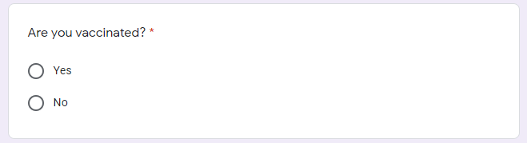

Question 2. 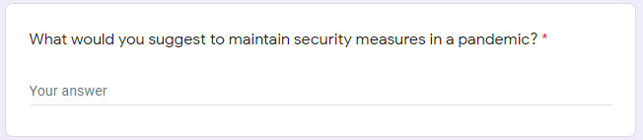

Question 3. 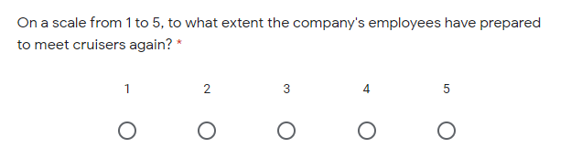

Question 4.

*Questions for cruisers.*

Question 1.

Question 2.

Question 3.

Question 4.

Question 5.

Question 6. 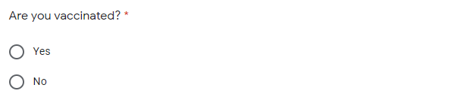

*Questions for non-cruisers.*

Question 1.

Question 2.

Question 3.

Question 4.

1. Transportation Research Interdisciplinary perspectives Volume 9 [https://www.sciencedirect.com/science/article/pii/S259019822100035X#](https://www.sciencedirect.com/science/article/pii/S259019822100035X)
2. <https://fortune.com/2021/01/11/carnival-cruises-covid-19-losses-q4-earnings/>
3. <https://www.ncbi.nlm.nih.gov/pmc/articles/PMC2775782/>
4. <https://www.bbc.com/news/business-55022158>
5. <https://www.carnivalcorp.com/corporate-information/our-brands>
6. <https://www.carnivalcorp.com/corporate-information#:~:text=Carnival%20Corporation%20employs%20a%20talented,the%20overall%20global%20cruise%20market>
7. <https://www.nejm.org/doi/full/10.1056/nejmms2033790#article_citing_articles>
8. <https://salvageheadlines.blogspot.com/2021/07/carnival-cruise-covid-requirements.html?c=1>